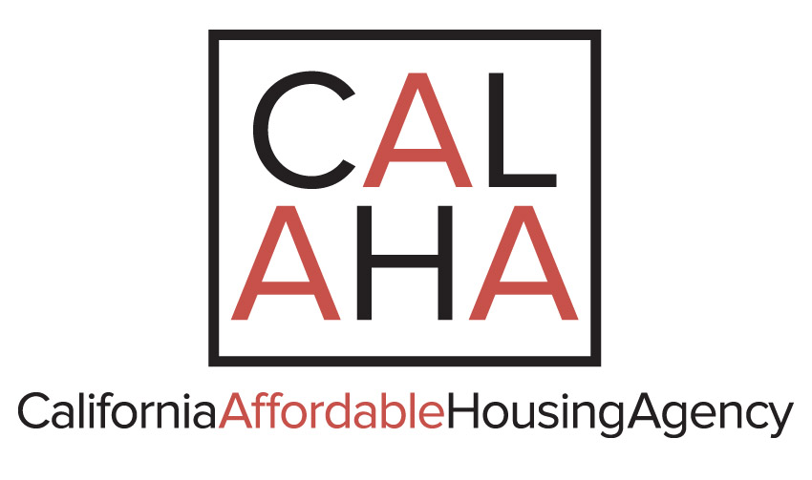

AGENDA
THE EXECUTIVE COMMITTEE OF THE BOARD OF DIRECTORS
CALIFORNIA AFFORDABLE HOUSING AGENCY
EXECUTIVE BOARD MEETING
July 8, 2019
10:00 a.m.
806 W. 19th Street
Merced, CA 95340
(209) 354-3000

TELEPHONIC LOCATIONS

2039 Forest Avenue Suite 10 1701 Robertson Blvd.
Chico, California 95928 Modesto, California 95351

1402 D Street 1400 West Hillcrest Drive
Brawley, California 92227 Newbury Park, California 91302

448 South Center Street
Stockton, California 95203

I. CALL TO ORDER AND ROLL

II. DIRECTORS’ AND/OR AGENCY ADDITIONS/DELETIONS TO THE AGENDA

(M/S/C): _____/_____/_____

III. APPROVAL OF MEETING MINUTES

1. June 10, 2019 Meeting

(M/S/C): _____/_____/_____

IV. UNSCHEDULED ORAL COMMUNICATIONS

NOTICE TO THE PUBLIC

At this time, any person(s) may comment on any item that is not on the Agenda. Please state your name and address for the record. Action will not be taken on an item that is not on the Agenda. If it requires action, it will be referred to Staff and/or placed on the next Agenda. In order that all interested parties have an opportunity to speak, please limit comments to a maximum of five (5) minutes.

V. FINANCIAL REPORT OF ADMINISTRATOR

Current Financials of the Agency

VI. RESOLUTION, ACTION AND INFORMATION/DISCUSSION ITEMS

A. RESOLUTIONS

None.

B. ACTION ITEMS:

Action Item 2019-01
Proposal for consideration of rental space for CalAHA to utilize as office for
development services

C. INFORMATION/DISCUSSION ITEM(S)

1. Nick Benjamin Report on Development;
2. Current update on Trio Program;
3. Current update on prospective projects and financings;
4. Current update on member projects and administrative matters.

VII. CLOSED SESSION

None.

VIII. DIRECTORS’ COMMENTS

IX. SCHEDULING OF FUTURE EXECUTIVE BOARD MEETINGS

(The second Monday of the month):

August 12, 2019, September 9. 2019, October 14, 2019, November 18, 2019 and December 9, 2019

X. ADJOURNMENT

